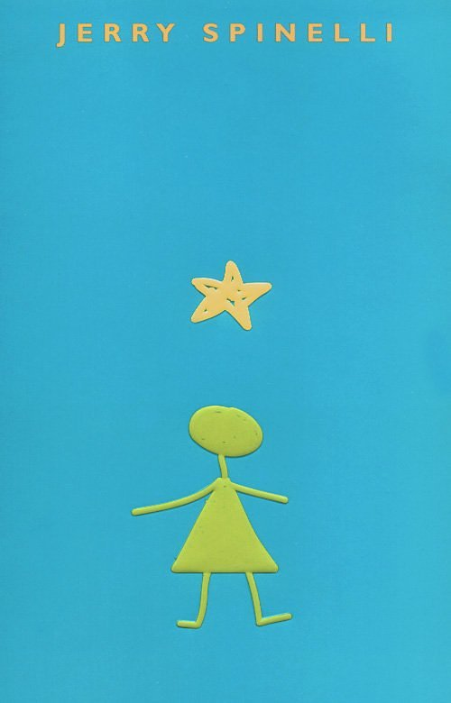

Stargirl by Jerry Spinelli
Student Journal

Name_____________________________________________________Class________________

TTQA—Don’t forget to “Turn The Question Around

Porcupine Necktie - Chapter 4
1.Who was Leo Borlock?
__________________________________________________________________________________________________________________________________________________________________________________________________________________________________________
2.What was Leo’s going away present from his uncle Pete? What mysterious gift appeared on Leo’s doorstep on his birthday?
________________________________________________________________________________________________________________________________________________________________________________________________________________________________________________________________________________________________________________________
3. Identify Stargirl.
__________________________________________________________________________________________________________________________________________________________________________________________________________________________________________
4. Identify Hot Seat.
__________________________________________________________________________________________________________________________________________________________________________________________________________________________________________
5.What unusual thing did Stargirl do in the lunchroom on the first day of school?
__________________________________________________________________________________________________________________________________________________________________________________________________________________________________________
6. List at least three unusual things Stargirl did in the first weeks of school?
__________________________________________________________________________________________________________________________________________________________________________________________________________________________________________
7. List four of the rumors going around school about Stargirl.
________________________________________________________________________________________________________________________________________________________________________________________________________________________________________________________________________________________________________________________

TTQA—Don’t forget to “Turn The Question Around

Chapters 5-9

- What did Stargirl do that attracted so much attention at the football game? What was the result of Stargirl’s halftime show?
________________________________________________________________________________________________________________________________________________________________________________________________________________________________________________________________________________________________________________________
- Identify Archie. Describe Archie’s “school.”
__________________________________________________________________________________________________________________________________________________________________________________________________________________________________________
- What did Stargirl do at her first football game as a cheerleader?
__________________________________________________________________________________________________________________________________________________________________________________________________________________________________________
- Identify Cinnamon.
____________________________________________________________________________________________________________________________________________________________
- Who won the oratorical contest at MAHS?
____________________________________________________________________________________________________________________________________________________________
- What change took place in the students in the last weeks of December into January?
______________________________________________________________________________________________________________________________________________________________________________________________________________________________________________________________________________________________________________________________________________________________________________________________________

TTQA—Don’t forget to “Turn The Question Around

Chapters 10-13

1. What day was Stargirl scheduled to go on Hot Seat?
_____________________________________________________________________________
_____________________________________________________________________________
2. Who was the unexpected, unwelcome mourner at Anna Grisdale’s grandfather’s funeral?
_____________________________________________________________________________
______________________________________________________________________________
3. What happened to Danny Pike? What happened to Danny’s new bike? _____________________________________________________________________________
_____________________________________________________________________________
_____________________________________________________________________________
_____________________________________________________________________________
4.What was unusual about Stargirl’s cheerleading? What was the reaction of most students when Stargirl would cheer for them?
_____________________________________________________________________________
____________________________________________________________________________________________________________________________________________________________
5. Of all the unusual things about Stargirl what struck the narrator as the most remarkable?
_____________________________________________________________________________
____________________________________________________________________________________________________________________________________________________________6. What trick did the basketball team and cheerleaders play on Stargirl? _____________________________________________________________________________
____________________________________________________________________________________________________________________________________________________________

7. What was the job of the hot seat jury?
_____________________________________________________________________________
____________________________________________________________________________________________________________________________________________________________

8. Why did the narrator secretly wish no one would watch the Stargirl Hot Seat episode?
_____________________________________________________________________________
____________________________________________________________________________________________________________________________________________________________

9. What other names had Stargirl used?
_____________________________________________________________________________
____________________________________________________________________________________________________________________________________________________________

10. What was Stargirl’s philosophy about her name?
_____________________________________________________________________________
__________________________________________________________________________________________________________________________________________________________________________________________________________________________________________

11. What did the Hot Seat jury do to Stargirl? _____________________________________________________________________________
________________________________________________________________________________________________________________________________________________________________________________________________________________________________________________________________________________________________________________________

TTQA—Don’t forget to “Turn The Question Around

Chapters 14-17
1. At the end of the second play of the game against Glendale, what happened to Stargirl?
_____________________________________________________________________________
________________________________________________________________________________________________________________________________________________________________________________________________________________________________________________________________________________________________________________________

2. What was Stargirl’s Valentine message to Leo? What was Leo’s reaction to Stargirl’s Valentine message?
_____________________________________________________________________________
____________________________________________________________________________________________________________________________________________________________
_____________________________________________________________________________
____________________________________________________________________________________________________________________________________________________________

3. Describe Leo’s encounter with Stargirl the first time he went to her house.
_____________________________________________________________________________
____________________________________________________________________________________________________________________________________________________________4.Describe the enchanted place Stargirl took Leo to in the desert.
_____________________________________________________________________________
________________________________________________________________________________________________________________________________________________________________________________________________________________________________________________________________________________________________________________________

TTQA—Don’t forget to “Turn The Question Around
Chapters 18-21

1. How did Leo feel about getting the silent treatment?
__________________________________________________________________________________________________________________________________________________________________________________________________________________________________________
2. How did Stargirl feel about getting the silent treatment?
__________________________________________________________________________________________________________________________________________________________________________________________________________________________________________
3. What did Stargirl teach Leo? ________________________________________________________________________________________________________________________________________________________________________________________________________________________________________________________________________________________________________________________
4. Who gave Leo the porcupine necktie? __________________________________________________________________________________________________________________________________________________________________________________________________________________________________________
5. Why did Stargirl drop money coins here and there? ________________________________________________________________________________________________________________________________________________________________________________________________________________________________________________________________________________________________________________________

TTQA—Don’t forget to “Turn The Question Around
Chapters 22-25
1. Why was Leo surprised at Stargirl’s house, parents and room?
__________________________________________________________________________________________________________________________________________________________________________________________________________________________________________
2. Identify Peter Sinkowitz.
__________________________________________________________________________________________________________________________________________________________________________________________________________________________________________

3. What was Leo’s reaction to Stargirl’s explanation of her Peter Sinkowitz project?
__________________________________________________________________________________________________________________________________________________________________________________________________________________________________________
4. What did the students say about Stargirl during the shunning period? __________________________________________________________________________________________________________________________________________________________________________________________________________________________________________
5. What was Leo’s reaction to the “Stargirl loves Leo” banner? __________________________________________________________________________________________________________________________________________________________________________________________________________________________________________
6. What was Leo’s crime? __________________________________________________________________________________________________________________________________________________________________________________________________________________________________________
7. When Stargirl forced Leo to talk to her about why he was avoiding her, what did he tell her? __________________________________________________________________________________________________________________________________________________________________________________________________________________________________________

TTQA—Don’t forget to “Turn The Question Around

Chapters 26-29
1. After Leo told Stargirl she should change, what did she do?
__________________________________________________________________________________________________________________________________________________________________________________________________________________________________________
2. What was Leo’s reaction to Susan?
__________________________________________________________________________________________________________________________________________________________________________________________________________________________________________
3. Did Stargirl’s change to Susan increase her popularity at school? __________________________________________________________________________________________________________________________________________________________________________________________________________________________________________

4. Why was Dori mad at Susan? __________________________________________________________________________________________________________________________________________________________________________________________________________________________________________
5. How did Susan behave in the car on the way to the contest? __________________________________________________________________________________________________________________________________________________________________________________________________________________________________________
6. What two birds did Susan talk about after the brief stop in the desert on her way to the
contest? __________________________________________________________________________________________________________________________________________________________________________________________________________________________________________

7. What was the title of Susan’s first speech at the contest? __________________________________________________________________________________________________________________________________________________________________________________________________________________________________________
8. How was Susan’s final speech different from the others at the contest?
__________________________________________________________________________________________________________________________________________________________________________________________________________________________________________

TTQA—Don’t forget to “Turn The Question Around

Chapters 30 – More Than Stars
1. Who returned to school Monday after the contest?
__________________________________________________________________________________________________________________________________________________________________________________________________________________________________________
2. Describes Stargirl’s presence at the Ocotillo Ball.
__________________________________________________________________________________________________________________________________________________________________________________________________________________________________________
4. What happened to Stargirl after the dance?
__________________________________________________________________________________________________________________________________________________________________________________________________________________________________________
5. Where was Stargirl’s secret office? What was in Stargirl’s office?
____________________________________________________________________________________________________________________________________________________________________________________________________________________________________________________________________________________________________________________________________________________________________________________________________________________________________________________________________________________
6. What is the Sunflower Club?
__________________________________________________________________________________________________________________________________________________________________________________________________________________________________________7. After time passed, Stargirl’s mark was left on the school. What things showed this?
__________________________________________________________________________________________________________________________________________________________________________________________________________________________________________

